Table of Contents

Revisions 3

References 4

General Description 5

Vessel Characteristics 5

Loadline Data 5

Downflooding Points 5

General Notes 6

Objective 6

General Instructions for Loading 6

Operating Instructions 8

Cross Connect Valve Remote Operator Locations 11

Instructions for Determining Stability, Trim, and Heel 14

Determine Displacement and Trim from Observed Drafts 18

Action Following Damage 20

Table of Hydrostatics 22

Trim Table 23

Allowable KG Curve 24

Tank Capacity Table and Plan 25

Table of Cargo & Storage Spaces 28

Increase in GM by Filling Tanks 29

GM Change Due to Adding 10 LT Weight 30

Icing Guidance 31

Allowable KG Curve with Icing 32

Blank Loading Worksheets 33

Sample Loading Conditions 36

Allowable KG with Load Conditions 37

Lightship Condition 38

Condition 1 – Full Load Departure 41

Condition 2 – Full Load Departure with Ice 44

Condition 3 – Mid Voyage 47

Condition 4 – Mid Voyage with Ice 50

Condition 5 – Arrival 53

Condition 6 – Arrival with Ice 56

Draft Marks 59

General Arrangement 60

# Revisions

|  |  |  |  |
| --- | --- | --- | --- |
| Revision # | Date | Sheet | Description |
| - | 12/6/2013 | ALL | Initial issue |
| A | 2/3/2014 | Var.  5  5  5  Var.  6  14  20 | Corrected LCG on pages 5,33,36,38,41,50,53,56  Corrected Lightship Displacement to match Inclining  Added Lightship TCG to Vessel Characteristics Table  Modified Midship Location per ABS Load Line Letter dtd 04December 2014  Added “k” factor to Anti-Roll Tank  Modified Free Surface Instructions in General Instructions 6 and 8  Correct FSM Calculation Instruction  Modified Action Following Damage Instruction 3 |

# References

1. Booklet of Tank Sounding Tables, 0650-835-03, Rev B dated 9 December 2013
2. Inclining Experiment Report, TR 097-002-7
3. Trim & Stability Supporting Data Calculations, 0650-843-04, Rev (-) dated 18 September 2011
4. Damage Equalization Calculations, 0650-843-05, Rev A dated 16 February 2012
5. General Arrangements, 0650-601-01, Rev E dated 8 October 2013
6. Remote Valve Operators 0650-505-03, Rev dated 5 October 2013
7. ABS Letter Reference T1099664, dated 1 November 2013

# General Description

## Vessel Characteristics

|  |  |
| --- | --- |
| Vessel | R/V Sikuliaq |
| Type | Oceanographic Research Vessel |
| IMO No. | 9578945 |
| Owner/Operator | Marine Superintendent  Seward Marine Center  201 Railroad Avenue  Seward, AK 99664 |
| Original Builder | Marinette Marine Corp. |
| Hull No. | 0650 |
| Class | ABS, ✠A1 E Oceanographic Vessel, ✠AMS, ✠ACCU, ✠DPS-1, Unrestricted Service, Polar Class PC5 |
| LOA | 261’-6” |
| LBP | 239’-11” |
| Breadth, molded | 52’-0” |
| Depth at side, molded | 28’-0” |
| Midships location | 116’-0 11/16” Aft of FP (11/16” AFT FR 58) |
| Forward perpendicular location | FR 0 |
| Frame spacing | 2’-0” |
| Maximum molded draft | 20’-0” |
| Loadline displacement | 4,215 Long Tons |
| Lightship displacement | 2,683.23 LT |
| Lightship LCG | 115.04’ aft of FP (1.65’ Fwd of Midships) |
| Lightship VCG | 24.06’ above baseline |
| Lightship TCG | 0.56’ Port of Centerline |
| Lightship draft (at LCF) | 14.62’ |
| Lightship and Inclining Test | 6 October 2013 |

## Loadline Data

The maximum extreme Load Line draft is 20’-0 7/16”. Trim should not exceed 2’-0” by the bow or 2’-0” by the stern.

## Downflooding Points

The downflooding point is the Flag Block on Main Deck at approximately Frame 86; 172.6’ aft of the forward perpendicular.

# General Notes

## Objective

1. This book is designed to help the ship’s Master maintain the satisfactory stability of his vessel for all conditions by heeding the restrictions as outlined below and by following the instructions for determining the ship’s trim and stability contained in the next section. This manual is not intended to replace the judgment of the person in charge, who must use every means at his/her disposal to ensure that the stability of the vessel is adequate to meet the sea and weather conditions encountered.
2. It is the Master’s responsibility to maintain the vessel in a satisfactory stability condition at all times, meeting the U.S. Coast Guard wind heel and righting energy requirements, towing requirements, lifting requirements, as well as a one-compartment standard of damage stability per 46 CFR Part 171.

Per 46 CFR 196.15-7; After loading and prior to departure and at other times necessary to assure the safety of the vessel, the Master shall determine that the vessel complies with all applicable stability requirements in the vessel’s Trim and Stability Booklet, Stability Letter, Certificate of Inspection, and Load Line Certificate as the case may be. The vessel may not depart until it is in the compliance with applicable stability requirements. The vessel’s draft, trim, and stability must be determined as necessary. The Master must enter an attestation statement in the log verifying that the vessel complies with the applicable stability requirements at the times specified. Any stability calculations made in support of the determinations must be retained on board for the duration of the voyage.

## General Instructions for Loading

1. Compliance with the stability criteria does not prevent capsizing regardless of the circumstance or absolve the Master of his responsibilities. The Master shall therefore exercise prudence and good seamanship, with regard to the prevailing circumstances, the season of the year, the weather forecasts, and the navigational zone when determining appropriate vessel loading, speed, or course.
2. This Trim and Stability Booklet incorporates data from the Inclining Experiment Report. Any changes made to the vessel after the date of the inclining shall void this report.
3. All tons used in this booklet are Long Tons (LT) of 2240 pounds.
4. The KG calculated in each condition must be less than the allowable KG (KGallow) values plotted on Sheet , for the particular displacement.
5. The Allowable KG Curve (Sheet 24) has not been corrected for a free surface moment. Therefore, the free surface moment for all tanks must be calculated. See the Operating Instruction for restrictions on tank loading.
6. A water tank less than 100% full or a fuel tank less than 95% full shall be considered slack. Miscellaneous oil and dirty tanks less than 98% full shall be considered slack. The free surface moment for any slack tank shall be the maximum value. The FSM for the Anti Roll Tank at the 70% operating level shall be the corrected FSM as defined in Instruction 9.
7. The vertical Free Surface Moment (FSM) for any water tank either empty or 100% full shall be zero.
8. The FSM for fuel tanks 95% full shall be the actual value (Sheet 25). The FSM for miscellaneous oil and dirty tanks 98% full shall be the maximum value. The FSM shall not be less than 4584.30 LT-ft.
9. The Vessel is equipped with an anti-roll tank with the following characteristics when filled to 70% with fresh water:

Weight 106.22 LT

(FW at 8’-11 ½” Stbd Sound, 9’-0 ½” Port Sound, 70%)

VCG 8.42 ft ABL

LCG 143.48 ft aft of the FP

FSM 3304.4 LT-ft

1. The stability of the vessel should be checked periodically throughout a voyage as fuel is consumed and the ballast is added or any time a major weight shift is anticipated on the vessel.
2. Calculations indicate this vessel will have no more than 10 degrees of list under ideal conditions after damage when the damage is limited to any one major compartment and not extends more than 10.4 ft inboard from the side of the hull. No Main Transverse Watertight Bulkheads are considered damaged. The bulkhead deck is the 01 Level form the bow to Frame 7. Aft of Frame 7, the bulkhead deck is the Main Deck. Main Transverse Watertight Bulkheads that are aft of Frame 7 are watertight to the Main Deck. A major compartment is the space between any two adjacent Main Transverse Watertight Bulkheads (MTWB). For this vessel the MTWBs are located at Frames 7, 21, 30, 40, 67, 76, 85, 94, 103, and 114.
3. If the vessel undergoes any modifications where large weight changes occur, the vessel shall have a Deadweight Survey and Inclining Experiment done under supervision of the U.S. Coast Guard to verify the lightship characteristics.
4. All ballast and fuel oil cross connect valves shall remain closed in normal operating conditions. See Operating Instructions for action following damage. The cross connect valves are remotely operated and the locations are shown on Sheets 11 to 13.
5. Cranes shall be used one at a time and not operated simultaneously with any other lifting device. The maximum lifting heeling moment is not to exceed 643 LT-ft.
6. Conditions favorable to ice formation require precautions. When arrival in sheltered waters is not imminent, stability improvement measures should be considered, and ice removal procedures should be initiated early so that substantial amounts do not accumulate. Recommend filling the anti-roll tank in icing conditions.

# Operating Instructions

1. Route – Operation on exposed waters is permitted. Since the vessel’s route is based on other considerations in addition to stability, the Master is cautioned that the route may be further limited to that specified on the Certificate of Inspection.
2. Personnel – A maximum of 46 persons may be carried. Since the personnel capacity based on other considerations in addition to stability the Master is cautioned that the number of persons carried may be limited on the Certificate of Inspection.
3. Freeboard and Draft – The maximum average molded draft of 20’-0” above baseline is permitted (20’-0 7/16” above the keel). This corresponds to a displacement of approximately 4215.13 LT in salt water.
4. Watertight Doors and Bulkheads – No watertight bulkheads or doors shall be removed, added, or altered with the authorization and supervision of the Cognizant Coast Guard OCMI. On the bulkhead aft of the helm station, a panel indicated whether the doors are open or closed.
5. Damage Survival – To maintain the vessel upright after flooding, the heeling forces imposed by wind, wave, and personnel movements must be minimized. The calculations do not specifically account for high waves, heavy seas, or the movement of personnel to one side. Also see Action Following Damage on Sheet .

The vessel is equipped with two (2) Type III watertight doors on Second Platform located at frames 30 and 40, and nine (9) Type III watertight doors on First Platform located at frames 21, 30 (P/S), 40, 67, 76, 85, 94, and 103. If damage is sustained, these doors shall be closed immediately either remotely or locally.

The vessel is equipped with ten (10) cross-connected tanks with equalizing valves and one (1) cross connected void. The tanks which have equalizing provisions are the Ballast 4-30-1/2 P/S, Fuel Oil 3-30-1/2 P/S, Void 4-40-1/2 P/S, Ballast 4-58-1/2 P/S, Ballast 4-67-1/2 P/S, Fuel Oil 3-67-1/2 P/S, Ballast 4-67-1/2 P/S, Fuel Oil 3-78-1/4 P/S, Ballast 3-87-1/2 P/S, Fuel Oil 4-94-1/2, P/S. Remote Motor Operators to activate these valves are located on Main Deck as follows:



These equalizing valves should remain closed at all times, except after hull damage occurs. The following procedure should be followed if hull damage occurs:

1. For all tanks with equalizing provision (listed above) which are empty, their respective equalization values should be opened.
2. The integrity of the remaining cross-connected tanks should be assessed. If the tank is damaged, the equalizing valve must be opened. If the tank is not damaged, the equalizing valve must remain closed.

Tank damage may be assessed by use of the tank level indicators, physical soundings, or visual inspection.

1. Deck Equipment – All deck equipment must be positively secured against shifting before leaving protected waters.
2. Hull Openings – Any openings that could allow water to enter the hull or deckhouse shall be kept closed at all times expect when actually used for transit under safe conditions. This includes the Main Deck or 01 Level hatches and weather doors to the forecastle and machinery spaces, which are assumed to be closed in the stability analysis.
3. Tanks – No more than one centerline or P/S pair of fuel oil storage tanks (excluding service tanks) may be partially filled at one time. If one tank of a P/S pair if full and the other is pumped to a minimum content, this need not be considered as a partially full pair of tanks.

When salt water ballast is carried, all ballast tanks that contain liquid should be pressed up whenever possible in order to minimize free surface. During ballasting a reduction in the vessel’s GMt due to slack tank free surface will occur until the tanks are pressed up. This temporary loss of GMt is equal to the salt water FSM of the tank (or tanks) divided by the vessel’s displacement at the time of ballasting.

Empty ballast tanks should be pumped periodically to assure a minimum content at all times.

All ballast and fuel oil cross connect valves shall remain closed.

Tanks equipped with Tank Level Indicators are shown in the following table. TLIs read out in the Engineer’s Control Room, the Bridge, and the Science Control Room.



1. Weight Changes –No fixed ballast or other such weight shall be added, removed, altered, and/or relocated without the authorization and supervision of the Cognizant Coast Guard OCMI.
2. Bilges – The vessel bilges and voids shall be kept pumped to a minimum content at all times.
3. Freeing Ports – Deck freeing ports shall be maintained operable and completely unobstructed at all times.
4. List – The Master shall make every effort to determine the cause of any list of the vessel before taking corrective action.
5. Trim – Trim shall be minimized.
6. Definitions – The following definitions are used throughout this booklet:

ABL Above Baseline

ABS American Bureau of Shipping

AP Aft Perpendicular

BL Molded Baseline of Vessel

CFR Code of Federal Regulations

CL Centerline

d Distance between midship and the LCF

DISPL Molded Displacement

ft feet

FO Fuel Oil

FP Forward Perpendicular (Fr 0)

FR Frame

FSM Transverse Free Surface Moment

FSC Free Surface Correction

FW Fresh Water

GM Metacentric Height

GMavail Available GM

IMO International Maritime Organization

KG Vertical Center of Gravity above Baseline (also VCG)

KGavail Available KG

KGallow Allowable KG

KML Longitudinal Metacentric Height above the BL

KMT Transverse Metacentric Height above the BL

LCB Longitudinal Center of Buoyancy “a” (aft) or “f” (fwd) of FP

LCF Longitudinal Center of Flotation “a” (aft) or “f” (fwd) of FP

LCG Longitudinal Center of Gravity “a” (aft) or “f” (fwd) of FP

Lmom Longitudinal Moment

LBP Length between Perpendiculars

LO Lube Oil

LT Long Ton (2240 pounds)

LOA Length over All

LWL Length On Waterline

m Slope of the Waterline

MH1 Moment to Alter Heel One Degree

MT1 Moment to alter Trim One Inch

MTWB Main Transverse Watertight Bulkhead

OCMI U.S. Coast Guard Officer in Charge, Marine Inspection

SG Specific Gravity

SW Salt Water

T1 Average of the aft port and starboard draft mark readings

T2 Average of the fwd port and starboard draft mark readings

TAM Draft at aft Mark

TAP Draft at AP

TCG Transverse Center of Gravity

TFM Draft at forward Mark

TFP Draft at FP

TMM Draft at midship Mark

TL Trim Lever

TLCF Draft at LCF

Tm Mean Molded SW LCF Draft

TMID Draft at Midships

Tmom Transverse Moment

TPI Tons per Inch Immersion

USCG United States Coast Guard

VCB Vertical Center of Buoyancy

VCG Vertical Center of Gravity above Baseline (also KG)

Vmom Vertical Moment

SV Specific Volume (gallons/LT)

# Cross Connect Valve Remote Operator Locations

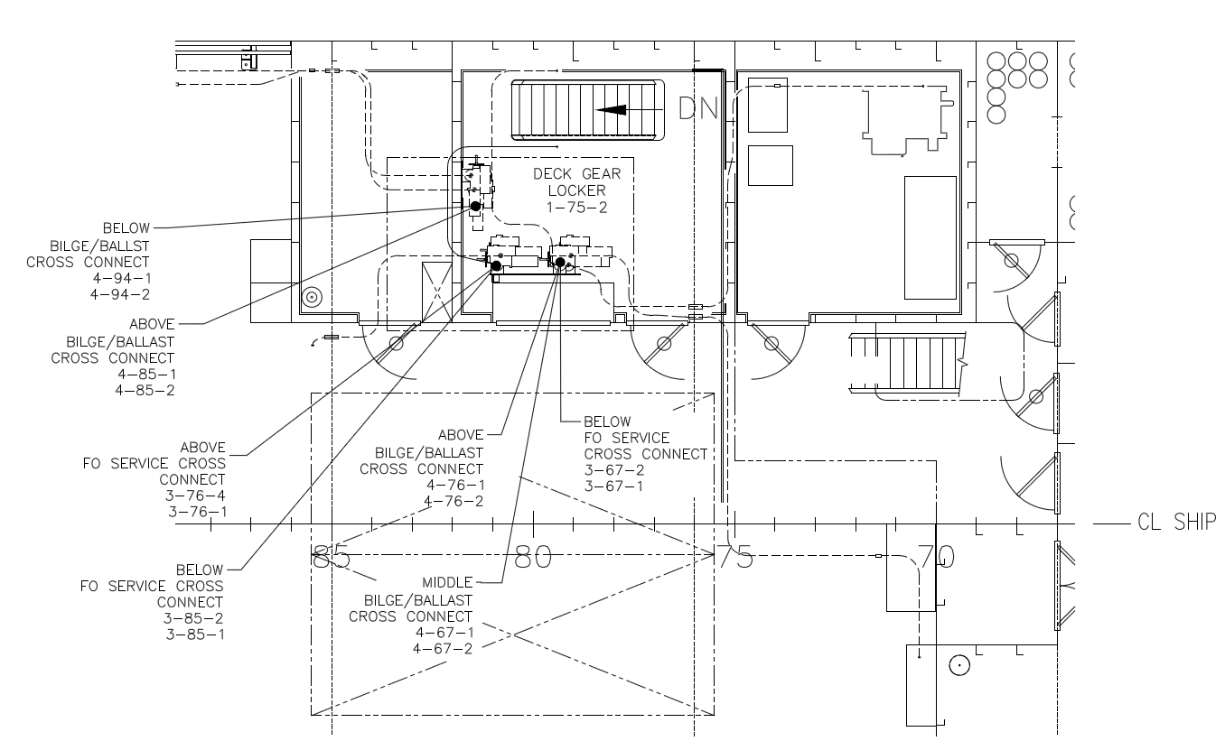

Cross Connect Valve remote operator locations for

FO Service 3-76-4 and 3-76-1

FO Service 3-85-2 and 3-85-2

FO Service 3-67-2 and 3-67-1

Bilge Ballast 4-94-2 and 4-94-1

Bilge Ballast 4-85-2 and 4-85-1

Bilge Ballast 4-76-2 and 4-76-1

Bilge Ballast 4-67-2 and 4-67-1

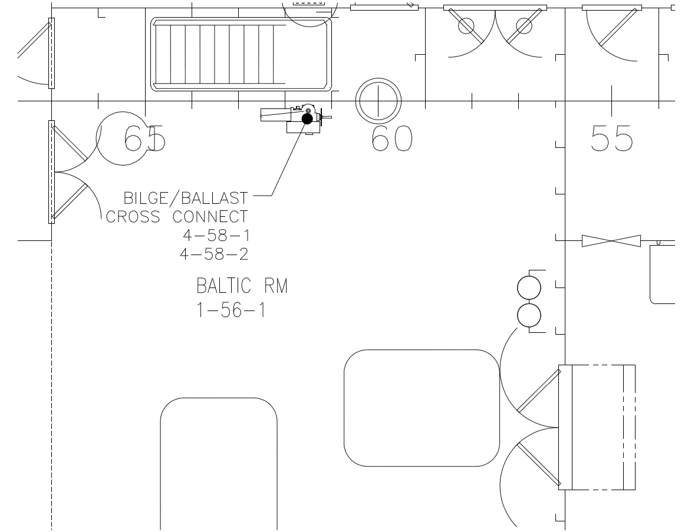

Cross Connect Valve remote operator location for

Bilge Ballast 4-58-2 and 4-58-1

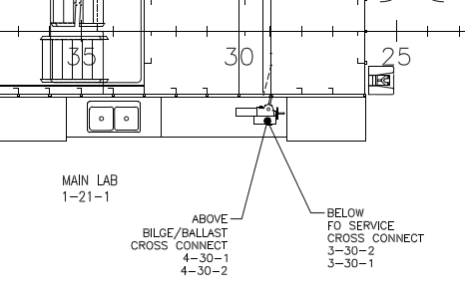

Cross Connect Valve remote operator location for

Bilge Ballast 4-30-2 and 4-30-1

FO Service 3-30-2 and 3-30-1

# Instructions for Determining Stability, Trim, and Heel

The following procedure has been used in solving the examples on Sheets 38 to 58 and shall be utilized to calculate the vessel’s displacement, center of gravity, and trim for any condition of loading. Blank loading forms are included on Sheets 33 to 35.

***Instructions for Computing Vessel Trim and Stability***

1. A typical condition is calculated by determining the amount and location of cargo on board, liquids in tanks, and stores. For this booklet the reference point is the intersection of a vertical line through the Forward Perpendicular (FP), the Centerline (CL), and molded baseline (BL). The FP is located at Frame 0. The VCG is referenced from the BL (positive up), and the TCG is referenced from CL (positive starboard).

Crane and A-Frame loads shall be accounted for by entering the weight of the load with a VCG and LCG of the load at the tip of the boom or top of the A-Frame into the loading worksheet.

The maximum heeling moment for lifting shall not exceed 643 LT-ft.

1. Calculate the Tank Loading by first locating the Tank Loading Worksheet (Sheet 34). Determine the loading fraction (percent full) for each tank on board. Use the Tank Capacity Table on Sheet 25 to establish the weight of liquid in each tank at 100% capacity and the VCG, LCG, and TCG. The weight of the liquid in each tank is calculated by multiplying the loading fraction by the weight of the liquid in the tank at 100% capacity. Enter the calculated weight of each tank liquid in the Weight Column of the Tank Load Worksheet. Enter the VCG, LCG, and TCG for each tank from the Tank Capacity Table.

Weight in tank = Loading Fraction x Weight at 100% tank capacity

Calculate the vertical, longitudinal, and transverse moments by multiplying the weight of the liquid in the tank by the center of gravity.

Vmom = Weight x VCG

Lmom = Weight x LCG

Tmom = Weight x TCG

The table below is a reference to the specific gravity (SG) and specific volume (SV) for liquids on board.



Enter the vertical Free Surface Moment (FSM) in the FSM Column of the Tank Load Worksheet. The FSM shall be calculated according to the following notes:

* There is no FSM for tanks that are empty or 100% full.
* A water tank less than 100% full or fuel tank less than 95% full shall be considered slack. Potable water tanks shall be considered slack at all times. Miscellaneous oil, waste, and fuel day tanks shall always be considered slack. The FSM of each slack tank shall be determined from the “Max” FSM Column of the Tank Capacity Table (Sheet 25).
* The FSM for fuel tanks 95% full shall be as indicated in the “95%” FSM Column of the Tank Capacity Table (Sheet 25).
* The total FSM for each type of liquid carried shall not be less than the values in the following table.



Next sum the FSM column on the Tank Load Worksheet. The minimum total FSM for any loading condition shall be 4584.30 LT-ft. If the specified FSM value is greater than the total FSM tabulated, substitute the specified minimum FSM value for the total FSM.

Sum the Weight and Moment Columns to obtain the subtotal for each type of tank. Divide the subtotaled moments by the subtotaled weights to determine the centroid of the tank type. Copy the Weight, Vmom, Lmom, Tmom, and FSM of the total tank load to the Summary Loading Sheet.

VCG = Σ Vmom / Σ Weight

LCG = Σ Lmom / Σ Weight

TCG = Σ Tmom / Σ Weight

1. Calculate the Mission Load by first locating the Mission Load Worksheet (Sheet 35). These loads should include Mission Loads and Expendables such as:
   1. Personnel and effects
   2. Working Deck Load
   3. Van Loads
   4. Scientific Stores
   5. Fishing gear
   6. Consumable stores and provisions
   7. Miscellaneous Cargo
   8. Any other items not included on the Tank Load Worksheet

The Mission Load Worksheet contains typical mission loads with a column indicating the maximum reference weight. If the typical mission loads are on board enter Y (yes) in the first column and enter the weight of the load in the Weight Column. Extra lines are included on the second page of the Mission Load Worksheet to take into account any weights not already listed on the worksheet. Enter the weight, VCGs, LCGs, and TCGs. The Mission Loads shall be calculated according to the following notes:

* All variable non-tank loads aboard the vessel are the be recorded on the Mission Loads Worksheets
* The vessel is designed to carry vans on Main Deck and the 02 Level. The vans are not part of lightship weight. The weight of vans is included in the 73 LT of Science Gear loaded on the Main Deck and is included in sample loading conditions
* To aid in determining the VCG of loads, the deck heights above the baseline are as follows:

DECK HEIGHT ABOVE BL

Tank Top 3’ – 6”

2nd Platform 10’ – 0”

1st Platform 19’ – 0”

Main Deck 28’ – 0”

01 Level 38’ – 0”

02 Level 47’ – 0”

03 Level 56’ – 0”

04 Level 65’ – 0”

05 Level 74’ – 0”

The Main Deck has 6” straight camber at centerline from waterline, aft of Frame 56.

The General Arrangements included on Sheets 60 to 68 will also aid in determining centers of Load Items.

The moments are calculated by multiplying the object weight by the center of gravity.

Vmom = Weight x VCG

Lmom = Weight x LCG

Tmom = Weight x TCG

Once the list is complete and the moments have been calculated, sum the Weight and Moment Columns. Divide each moment subtotal by the weight subtotal to determine the centroid of the Total Mission Load Weight. Copy the Total Mission Load Weight, Vmom, Lmom, and Tmom to the Summary Loading Sheet.

VCG = Σ Vmom / Σ Weight

LCG = Σ Lmom / Σ Weight

TCG = Σ Tmom / Σ Weight

1. Use the Summary Load Worksheet (Sheet 33) to determine the vessel load condition displacement and center of gravity. Enter the weight, Vmom, Lmom, Tmom, and FSM vales for the Tank Load and the Mission Load. The Icing weight should be determined based on the guidance on Sheet 31. Calculate the vertical, longitudinal, and transverse moments by multiplying the ice weight by the center of gravity.

Vmom = Weight x VCG

Lmom = Weight x LCG

Tmom = Weight x TCG

The Total Deadweight is calculated by summing the Tank Load, Mission Load, and Icing Load on the Summary Load Worksheet (Sheet 33). The Total Deadweight centroid is calculated by summing the moments and diving by the total weight. The Lightship characteristics are already included on the Worksheet. To calculate the Total Displacement (DISPL), sum the weight of the Total Deadweight and Lightship. The centeroid is calculated by dividing the moment subtotals by the total weight.

VCG = Σ Vmom / Σ Weight

LCG = Σ Lmom / Σ Weight

TCG = Σ Tmom / Σ Weight

1. Determine the trim at the existing vessel condition. Use the Table of Hydrostatics (Sheet 22) to determine the initial Mean Molded Salt Water Draft (Tm), Longitudinal Center of Buoyancy (LCB), and Longitudinal Metacentric Height (KML) and the Longitudinal Center of Floatation (LCF) by interpolating these values for the calculated Total Displacement. Calculate the Trimming Lever (TL) by subtracting the LCB from the LCG which may be positive or negative. Next calculate the Moment to alter Trim One Inch (MT1) by multiplying the difference of the Vertical Center of Gravity (VCG) and the Longitudinal Metacenteric Height by the Displacement and dividing by 12 times the Length between Perpendiculars (LBP). The Trim (TRIM) in feet is calculated by multiplying the Displacement by the Trimming Lever and dividing by 12 times the Moment to alter Trim One Inch. A positive answer is a trim by the stern, and a negative answer is a trim by the bow.

TL = LCG – LCB

MT1 = (KML – VCG) * DISPL / LBP / 12

TRIM = (DISPL x TL) / (12 x MT1)

LBP = 239.92 feet

1. The trim should not exceed 2 ft by the stern (+) or 2 ft by the bow (-). If changes to the trim are required, the Trim Table on Sheet 23 can be used to quickly determine the effect of weight changes. Note that the movement of any weight will require the stability to be re-calculated and re-checked.
2. Determine the expected average drafts at the forward perpendicular (TFP), aft perpendicular (TAP), forward draft mark (TFM), midship draft mark (TMM), and aft draft mark (TAM).

TFP = Tm – (TRIM / LBP * LFC)

TAP = TFP + TRIM

TFM = Tm – [ TRIM / LBP * (LCF – 14) ]

TMM = Tm – [ TRIM / LBP * (LCF – 122 ) ]

TAM = Tm – [ TRIM / LBP * (LCF -216 ) ]

1. Determine the stability of the vessel. The Free Surface Correction (FSC) is calculated by dividing the Total FSM by the Displacement. The Available KG (KGavail) is a measure of the stability of the vessel and is obtained by subtracting the Free Surface Correction from the Vertical Center of Gravity. The Allowable KG (KGallow) is interpolated from the Required KG Curve (Sheet 24).

FSC = Total FSM / DISPL

KGavail = VCG - FSC

The Required KG value (Sheet 24) must be greater than the Available KG, for the particular mean draft.

KGallow > KGavail

1. Determine the heel at the existing vessel condition. Determine the Transverse Metacentric Height (KMT) from the Table of Hydrostatics (Sheet 22). Calculate the Available GMt by subtracting the Available KG (KGavail) from the Transverse Metacentric Height (KMT). The Moment to alter Heel One Degree (MH1) is calculated by multiplying π/180 or 0.01745 times the Available GMt times the Displacement. To determine the heel, the total Transverse Moment (Tmom) is divided by the Moment to alter Heel One Degree. Heel can be positive or negative. This heel calculation method used GMt corrected the USCG free surface movement correction; it provides a conservative estimate of heel.

GMavail = KMT - KGavail

MH1 = GMavail x DISPL x 0.01745

HEEL = Total Tmom / MH1

1. Blank Load Condition Sheets (Sheets 33 to 35) are provided for calculating a particular condition not found within this Trim and Stability Booklet.

# Determine Displacement and Trim from Observed Drafts

The following procedure describes the method of determining displacement and trim from the observed drafts. Average port and starboard drafts are used to eliminate the effect of heel.

1. Determine the average of the aft port and starboard drafts (T1). The aft draft marks are centered at Frame 108.
2. Determine the average of the forward port and starboard drafts (T2). The forward draft marks are centered at Frame 7.
3. Calculate the slope of the waterline (m), which equals (T1) minus (T2) divided by the distance between the two drafts. A positive slope indicated trim by the stern, while a negative slope indicates forward trim,

m = (T1 – T2) / 202

1. Calculate the draft at the Forward Perpendicular (TFP)

TFP = m x 239.92 +T1

1. Calculate the draft at the Aft Perpendicular (TAP)

TAP = m x 23.92 +T1

1. Calculate the trim (TRIM) in feet over the 239.92 feet Length Between Perpendiculars (LBP)

TRIM = TAP -TFP

1. Calculate the Midship draft (TMID)

TMID = (TFP + TAP) / 2

1. Use the Table of Hydrostatics (Sheet 22) to determine the Longitudinal Center of Floatation (LCF) using the Midship draft (TMID) as the Mean Draft (Tm). Intermediate Values may be interpolated.
2. Calculate the distance between Midship and the LCF (d).

d = LCF – 119.96

1. Calculate the LCF draft (TLCF).

TLCF = TMID +d x m

1. Use the Table of Hydrostatics (Sheet 22) to determine the Displacement (DISPL) at the LCF draft (Tm). Intermediate values may be interpolated.

The following figure shows the relative location of the forward draft marks, aft draft marks, and reference points used in the displacement calculation above. The forward, midship, and aft draft marks are to baseline based on the centerboard in the flush position.

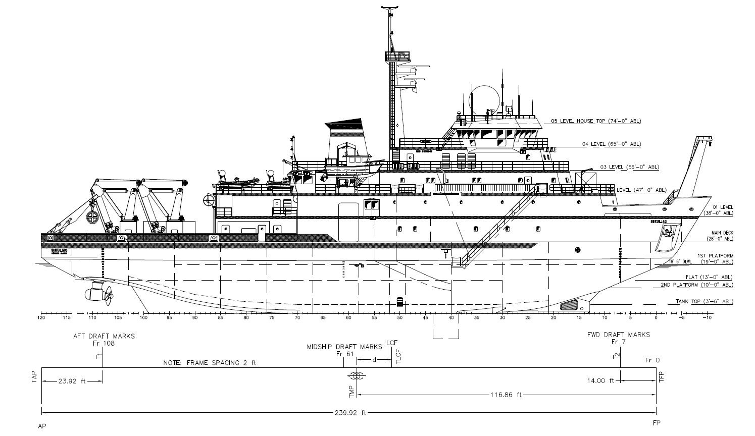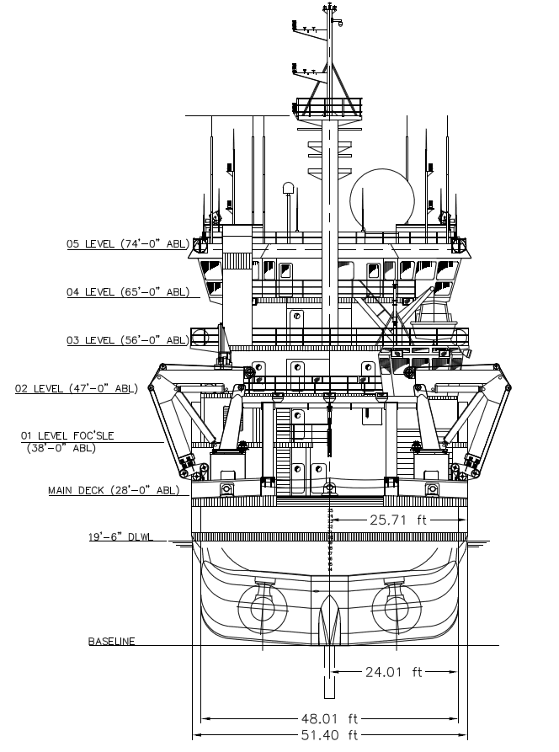

# Action Following Damage

In the event of underwater damage or entry of water through the weather envelope, stability of the vessel will be affected by the consequent flooding of spaces within the vessel. The R/V Sikuliaq is designed to comply with the USCG damage stability criteria with a one compartment standard of flooding.

The response of the vessel to flooding will depend on the intact draft, trim, and stability characteristics immediately prior to the incident, and the condition of the tanks, if any, involved in the flooding.

Entry of any significant amount of water into any part of the vessel should be regarded as an emergency situation and appropriate measures should be taken promptly. These would normally include the following:

1. Call for assistance.
2. Alert the vessel personnel to the situation.
3. Ensure that all watertight doors are closed. The vessel is equipped with eleven (11) Type III watertight doors located in MTWBs at Frames 21, 30, 40, 67, 76, 85, 94, and 103.
4. Favor stability in handling the vessel. Head into the wind and sea if possible. Avoid hard turns.
5. Determine the source of the flooding and the spaces affected or likely to be affected.
6. Activate the bilge system, emergency generator, and other emergency systems as required.
7. Establish flooding boundaries by shoring or patch to prevent or limit progressive flooding.
8. The following procedure should be followed if hull damage occurs:
   1. For all tanks with equalizing provision (listed below) which are empty, their respective equalization values should be opened.
   2. The integrity of the remaining cross-connected tanks should be assessed. If the tank is damaged, the equalizing valve must be opened. If the tank is not damaged, the equalizing valve must remain closed.



The locations of the Cross Connect Valve remote operator locations are shown on Sheets 11 to 13.

In general, further corrective action should be evaluated once trim and list reach as stead state without further increase. The corrective actions must be evaluated depending on the degree of the improvement in the vessel’s attitude deemed necessary in the circumstance. For example, if the stern is low in the water, trimming by the head may be considered. If the vessel lists heavily as a result of unsymmetrical flooding, list correction may be undertaken.

Trim and list corrections should generally be made by shifting liquids already on board rather than by taking on water ballast, which will increase the draft and reduce the reserve buoyancy. When shifting liquid, the following precautions should be observed.

1. DO NOT attempt to correct a list by shifting liquids if any signs of negative GMt are present. These signs include:
   1. A slow, erratic period of roll
   2. Failure to return to upright after rolling to one side, and
   3. Listing alternatively to port and starboard
2. If, and only if, it can be positively determined that a list due to unsymmetrical flooding and the vessel has a positive GMt, list correction by shifting of liquids may be undertaken slowly and cautiously.
3. Secure the Anti-Roll Tank control equipment to limit the free surface effect. Consider filling the tank to further reduce the free surface effect and increase stability.
4. Take suction from tanks which are already slack rather than tanks which are full. This will minimize the increase in free surface effect.
5. Discharge to tanks which are slack rather than tanks which are full. This will minimize the increase in free surface effect.
6. Favor improvements in trim, if possible, when selecting tanks for transfer.

Minor improvement in stability may also be accomplished by lowering moveable weights. For example, cranes, if initially up in the working position, may be lowered to the fully down position. In cases where survival takes precedence over all other considerations, heavy gear may be jettisoned, working from the upper decks down. Jettisoning is a slow and laborious operation and the improvement obtained will be usually small. Therefore is should only be considered in an extreme situation.

# Table of Hydrostatics

Hydrostatics are developed for zero trim. The hydrostatics are developed based on the molded lines, are for zero heel.



# Trim Table

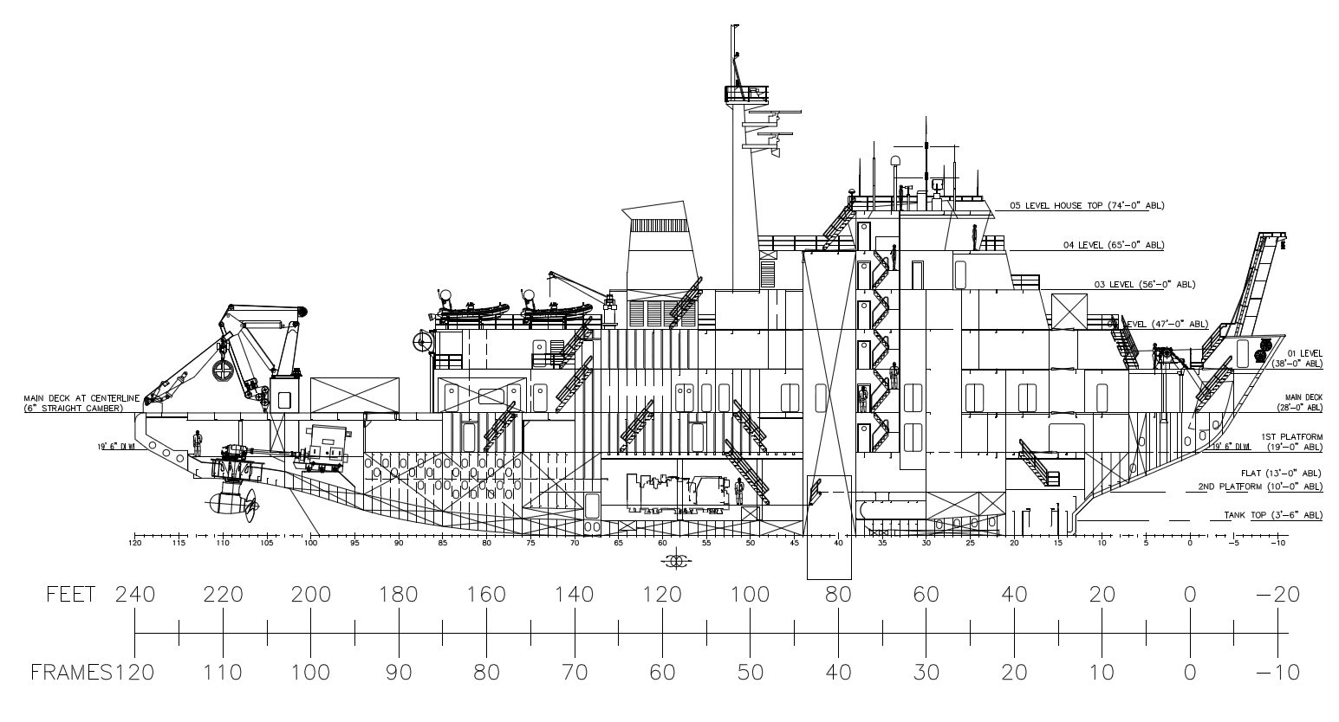

Table of trim correction in feet to the forward, midship, and aft draft marks for each 10 LT added



Example: Find the new drafts after loading 15 LT centered at Frame 71 with initial draft of 19 ft.



Notes:

1. The corrections have been computed for draft 18 ft and 19.4 ft. Use the corrections the draft closes to the actual initial draft of the vessel
2. When off loading, use the same corrections, but reverse the sign.

# Allowable KG Curve



# Tank Capacity Table and Plan

In the table below, the values for Ballast Tanks are 100% full, Fuel Tanks, 100%, Potable Water 100%, Oil Tanks 95%, Waste Tanks 100%, Stability Tank 70% and Other Tank 100%.



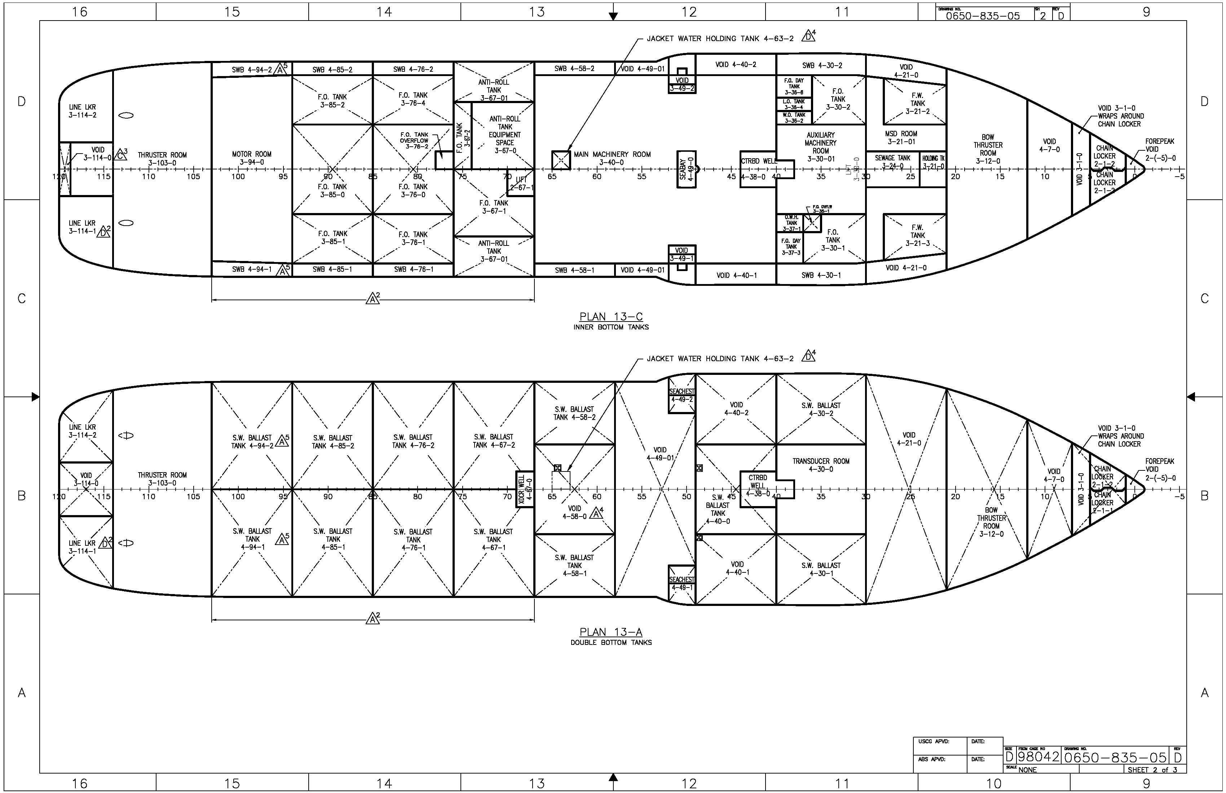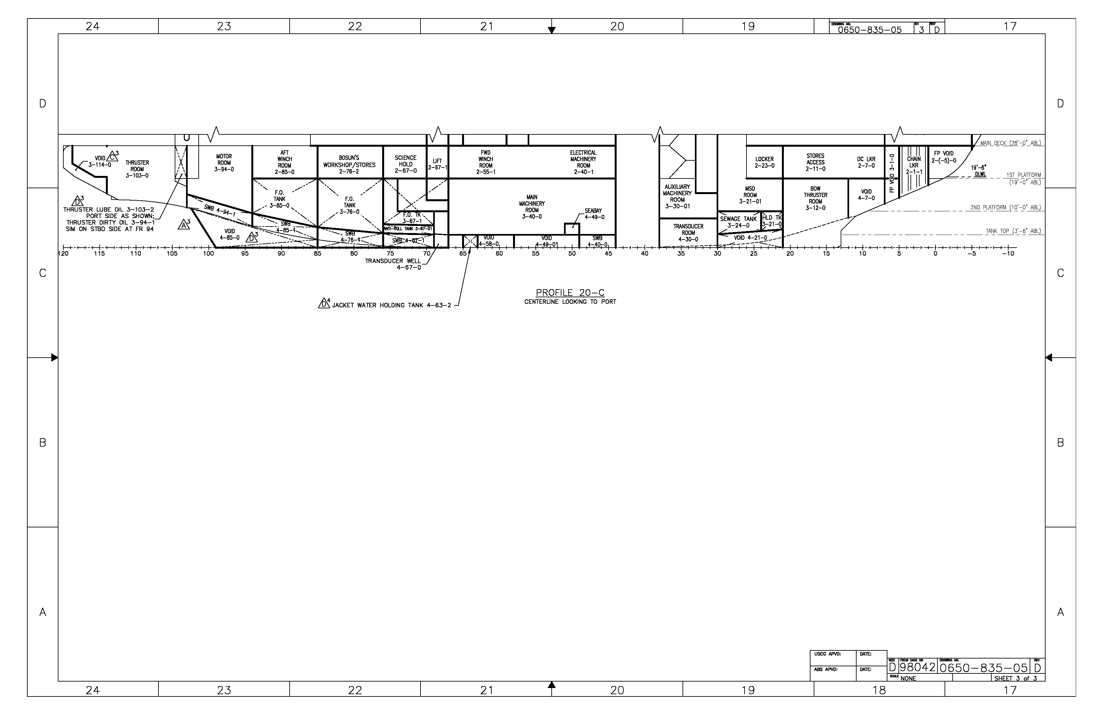

# Table of Cargo & Storage Spaces



# Increase in GM by Filling Tanks

This table shows the change in VCG for range displacement when tanks are filled. Values are in feet. A positive (+) value means the GM increases, which increases the vessel’s stability. A negative (-) value means the GM decreases, which reduces the vessel’s stability. Values are for a single tank containing the fluid in the tank.



# GM Change Due to Adding 10 LT Weight

The following table shows the change in GM resulting from an addition of 10 long tons. This facilitates estimating the effect on stability of weight changes at various levels, as from additional stores, deck cargo, etc. The change in GM is proportional for weights other than 10 long tons. When weights are removed, the change is the same as for weights added, but with the sign reversed. Added weight is assumed to have a VCG of 3 feet above the deck at each location cited. The table below assumes no trim and no heel. The weight is assumed to be added at the LCF.



# Icing Guidance

Any accumulation of ice topside will cause a reduction in the available KG. An approximation of this loss may be obtained by estimating the average thickness of ice over the exposed areas above the waterline, including masts, cranebooms, rails, rigging, etc. as well as bulkheads and decks. Based on USCG guidance it is assumed that the horizontal surfaces will be twice the thickness of build-up as that on as vertical surfaces.

The effect of topside icing on KG is shown on Sheet 32, with Departure, Mid Voyage, and Arrival conditions plotted with different thicknesses of ice accumulation of the Required KG Curve. The different thicknesses of ice accumulation shown on the curve are listed in the table below. Other thicknesses will have a proportional effect.



The magnitude of KG available loss indicates that significant accumulation of ice can result in a deficient stability condition. Conditions favorable to ice formation require precautions. When arrival in sheltered waters is not imminent, stability improvement measures should be considered, and ice removal procedures should be initiated early so that substantial amount do not accumulate.

The following plot shows the Departure, Mid Voyage, and Arrival conditions without icing, half the USCG Ice Load, and the full USCG Ice Load.

# Allowable KG Curve with Icing

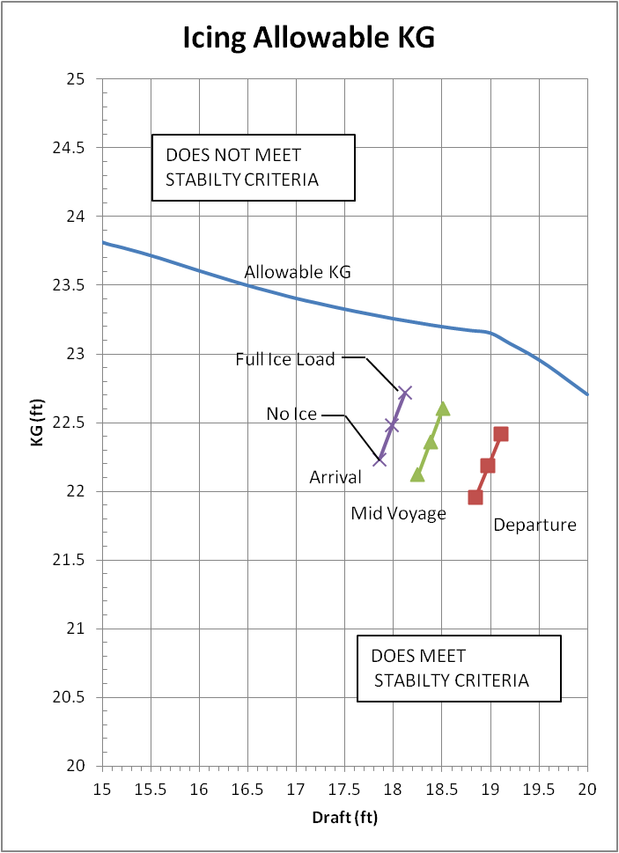

# Blank Loading Worksheets







# Sample Loading Conditions

The R/V Sikuliaq has six sample loading conditions, which include Full Load, Mid Voyage, and Arrival, with and without ice. The Lightship weight includes Damage Control Locker contents.



# Allowable KG with Load Conditions



## Lightship Condition



 

## Condition 1 – Full Load Departure







## Condition 2 – Full Load Departure with Ice



 

## Condition 3 – Mid Voyage



 

## Condition 4 – Mid Voyage with Ice





## Condition 5 – Arrival





## Condition 6 – Arrival with Ice







# Draft Marks

Draft marks are located at Frames7 (14 ft aft of FP), 61 (122 ft aft of FP), and 108 (216 ft aft of FP). The frame spacing is 24 in with the forward perpendicular at Frame 0. The draft marks are to the baseline of the vessel. Each letter is 6 in tall with 6 in spacing between the top of the number and the bottom of the next number. The bottom of the each number corresponds to the indicated draft.

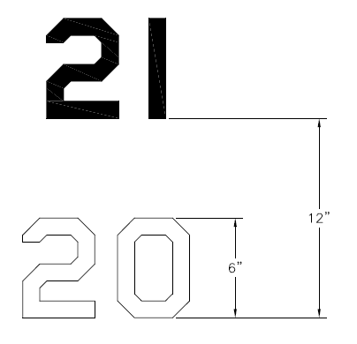

# General Arrangement

